2024

BARAKAH

MAGAZINE

For more info, visit www.barakah.com

•**"Living the Light: Stories of Faith and Purpose"**

•**"Guided by Grace: Lessons from the Heart"**

•**"Barakah in Every Step: Finding Blessings in the Everyday"**

Barakah

·Blessing is defined as the divine good displayed in something. It's an opportunity to express gratitude and appreciation for the good things, people, experiences, or circumstances that have positively impacted your life. ·In Islamic terminology especially in Sufism, there is a lot of attention given to what is called **Barakah** (blessing). In Islam, blessings (Barakah) are considered gifts from Allah that bring joy, prosperity, and spiritual growth. ·Types of Blessings: 1. Material blessings (rizq): wealth, health, family, children, and worldly success. 2. Spiritual blessings (Barakah): guidance, faith, piety, knowledge, and closeness to Allah. Blessing in daily life are Food and Drink, Sleep and Wakefulness, Travel, Family and Children, Health and Recover

# 

# **THE PILLARS OF ISLAM**

# The Pillars of Islam are the foundation of

# Muslims faith and practice. **Shahada (Faith)**,

Salah (Prayer), Zakat (Charity), Sawm (Fasting

During Ramadan), Hajj (Pilgrimage to Mecca.

These pillars are essential practices that shape

The ethical and spiritual framework of Muslims

Life. These five pillars are the great blessings of

Allah. These five pillars of Islam are more than

Obligations, they are seen as profound blessings

that enrich the spiritual life of Muslims.

**Islam** is itself a great blessing.

Islam is seen as a profound blessing by its followers, offering comprehensive guidance for living a balanced and meaningful life. It nurtures a direct relationship with Allah, providing spiritual peace and comfort. Through its teachings, Islam fosters unity and a sense of global brotherhood, promoting empathy, compassion, and generosity. It instills a sense of purpose and responsibility, encouraging believers to act ethically and be accountable for their actions. The practices of Islam, such as prayer and fasting, support discipline and holistic well-being, enriching both spiritual and daily life, and leading towards fulfillment and harmony.

**Water**

**the great**

**Blessing**

Water is often viewed as a symbol of Barakah (blessing) in cultural and religious contexts

Water is essential for life. It's availability and purity is great a great blessing not just for human beings but also animals and plants. Water is important for agriculture and food production. The presence of water in these respects is a divine blessing that leads to a fruitful harvest.

The most important thing about water is that it is used for drinking purpose which has great importance in our life. Allah asks us to reflect: "Say, ‘Tell me, if your water was to be sunk away, who then can supply you with flowing (spring) water?’" (**Quran, 67:30)**

**“And we have made from water every living thing. Then will they not believe?”**  
— **Surah Al-Anbiya (21:30)**

**House as a blessing**

A house is often considered one of the greatest blessings from Allah, serving not just as a physical shelter but also as a place of peace, comfort, and refuge. Homes are where families build memories, celebrate milestones, and support each other. In Islam, strong family bonds are highly valued, and a house becomes the backdrop for nurturing these relationships, fostering love, respect, and harmony.

A home can also be a place for spiritual reflection and growth. Muslims are encouraged to establish prayer (Salah) within their homes, creating an atmosphere of worship and connection to Allah. This spiritual dimension transforms a house into a place of blessings.

In Islam, being thankful for what one has is essential. Acknowledging the comfort and stability a home provides encourages a mindset of contentment and appreciation for Allah's bounties.

Homes are where families build memories, celebrate milestones, and support each other. In Islam, strong family bonds are highly valued, and a house becomes the backdrop for nurturing these relationships, fostering love, respect, and harmony.

Food as

A blessing

Allah’s boundless generosity and care for His creation. The Qur’an and Hadith frequently remind believers to appreciate and express gratitude for this essential provision. Every meal is an opportunity to reflect on the divine origin of nourishment, from the growth of crops and fruits to the complexity of the natural processes that bring food to the table. This recognition cultivates mindfulness, humility, and gratitude. The practice of saying “**Bismillah”** (In the name of Allah) before eating and “Alhamdulillah” (Praise be to Allah) after a meal is a way to acknowledge that sustenance comes from Allah alone.

Additionally, Islam encourages moderation and discourages wastefulness, as reflected in the verse, **“Eat and drink, but do not waste. Indeed, He does not like the wasteful”** **(Surah Al-A'raf 7:31).**

Sharing food, especially with those in need, is considered a virtuous act, reinforcing the importance of community and empathy. Overall, food in Islam is not just physical sustenance but a reminder of Allah’s provision, a means to strengthen social bonds, and a call to practice gratitude and responsible stewardship.

Food as a blessing in Islam encompasses prof Food spiritual, social, and ethical dimensions. It is recognized not just as a means of survival but as an avenue for expressing gratitude and fostering communal ties. The act of eating is imbued with rituals that remind Muslims of their dependency on Allah and the interconnectedness of life

Barakah

Before eating, saying “Bismillah” underscores the importance of remembering Allah, acknowledging His role as the ultimate Provider. After meals, saying “Alhamdulillah” reaffirms gratitude and prevents the complacency of taking food for granted.

**Allah says in Surah Al-Baqara (2:172)**: “**O you who have believed, eat from the good things which we have provided for you and be grateful to Allah if it is [indeed**]Him that you worship.”

Fasting during the month of Ramadan deepens the understanding of food as a blessing. Abstaining from food and drink from dawn until sunset not only teaches self-discipline and patience but also heightens awareness of the struggles faced by those who lack sufficient food. This experience fosters a stronger connection to those in need and inspires acts of charity and generosity, reinforcing the role of food as a means of social justice and compassion.

Islam also discourages excess and wastefulness, aligning with the Qur’anic instruction in **Surah Al-A'raf (7:31)**: “Eat and drink, but do not waste. Indeed, He does not like the wasteful.”

**PLANTS**

Plants are a profound blessing, representing the foundation of life and sustainability on Earth. They provide nourishment through fruits, vegetables, grains, and herbs, serving as the

Primary source of food for humans and animals alike. Beyond sustenance,

Plants contribute to clean air by

Absorbing carbon dioxide and relaxing oxygen, crucial for maintaining

the balance of the ecosystem. Their

roots prevent soil erosion and support water retention, which in turn ensures

That land remains fertile and productive.

Plants also offer medicinal properties,

With countless herbs and plant-based compounds being used in traditional

And modern medicine for healing and

Well-being. Spiritually and culturally,

Plants symbolize growth, resilience,

And the cycle of life, reminding people.

Of nature's interconnectedness and the importance of stewardship. In essence, plants are blessings that nurture life, promote health, and sustain..

NATURE

Nature offers an unparalleled array of beauty, from the vibrant colors of a sunset to the quiet stillness of a forest. This beauty is rooted in the vast diversity of ecosystems and species found on Earth. Forests, mountains, oceans, and deserts all have unique features, each home to various flora and fauna adapted to their specific environment.

Nature is a priceless blessing that surrounds us with its beauty, serenity, and life-sustaining resources. From the rustling of leaves to the gentle flow of rivers, it nurtures both our body and soul. It provides the air we breathe, the water we drink, and the food we eat, reminding us of its essential role in our lives. Nature’s diverse landscapes and vibrant ecosystems inspire awe and gratitude, offering solace and balance in our busy world.

**NATURE and BEAUTY**

Nature is one of the greatest blessings bestowed upon humanity by Allah. It is a source of sustenance, inspiration, and a reminder of the Creator's infinite wisdom and mercy. From the flowing rivers and lush greenery to the towering mountains and expansive skies, every element of nature reflects the beauty and perfection of divine creation. The intricate balance in ecosystems, the provision of food through the earth, and the life-giving properties of rain are all signs of Allah's blessings that call upon us to reflect and express gratitude.

***"And We sent down blessed rain from the sky and made grow thereby gardens and grain from the harvest."* (Surah Qaf 50:9)**

This verse highlights how rain, a fundamental element of nature, nurtures the earth and supports life. It reminds us of our responsibility to cherish and protect the environment as stewards of the Earth, maintaining its balance for future generations. Nature not only meets our physical needs but also nourishes the soul, inspiring a deep connection with the Creator and fostering humility, gratitude, and awe.

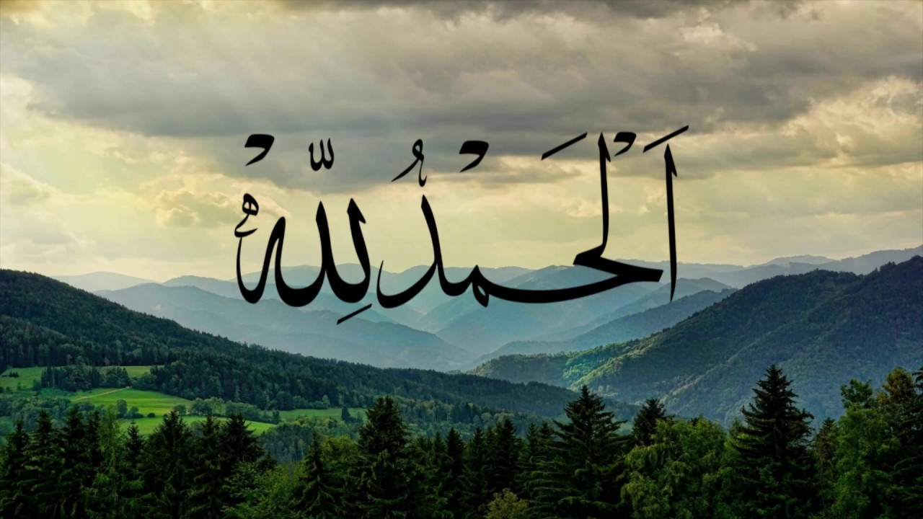***"Then which of the favors of your lord will you deny?"***

***Al- Quran (surah Rahman)***

**We must be thankful to ALLAH for his blessings upon us.**

Allah, the One, the Supreme,

Creator of all, the universe's theme.

Merciful and Just, His names we adore,

The Compassionate, the Benevolent, forever more.

**…………………………….**

In the Quran, His words we find,

Guidance for life, peace of mind.

The Prophet Muhammad, His messenger true,

Showed us the path, to follow Him anew.

**……………………………………**

Allah, the Protector, the Provider too,

Gives us life, and all we do.

His blessings abound, His mercy we see,

In every breath, a gift from He.

**……………………………………..**

So let us praise Him, with heart and soul,

Thank Him for all, our lives made whole.

For Allah is One, the Only One to adore,

The Almighty, the All-Powerful, forevermore

**BARAKAH** Magazine7

Published by: HAKIM group

Date of published: 20th November 2024

For more info, visit **www.barakah.com** and scan

The given QR code in order to buy it.